Friends of Tigger’s
(Princess location)
June 2026 Theme: Sunshine, Bugs and Garden Creatures
Sunday | Monday | Tuesday | Wednesday | Thursday | Friday | Saturday
 | 1  Summer colors | 2  Fireflies | 3  Make a pair of sunnies | 4  Handprint sun | 5  Creative art day | 6  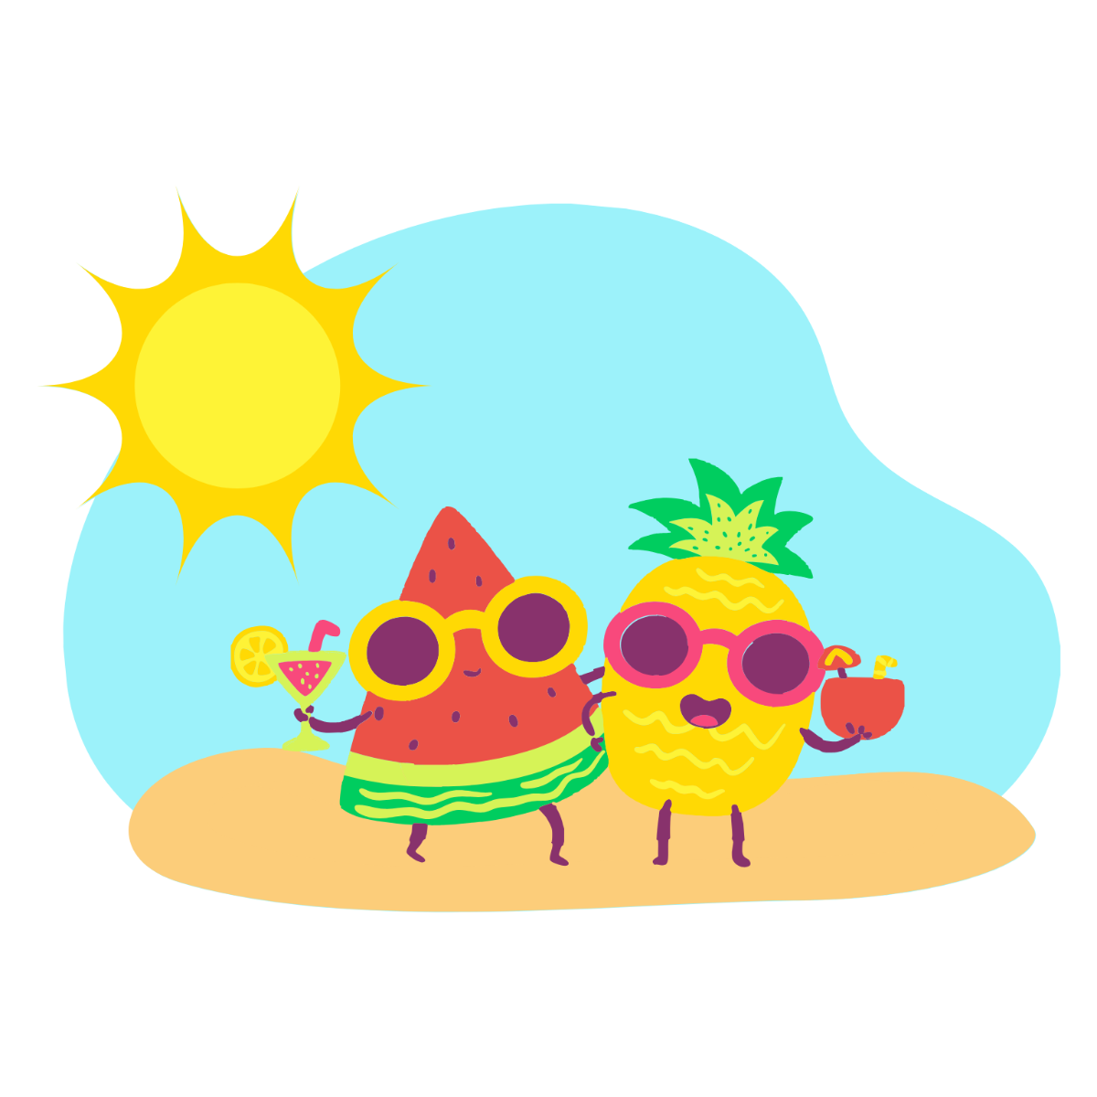
7 | 8  Watermelon craft | 9  Dragonfly popsicle stick craft | 10  My favorite summer activity drawing | 11  Popsicle stick picnic baskets | 12  Bug jars | 13
14   | 15  Pipe cleaner flowers | 16  Bow-tie art | 17  What I love about my dad/grandpa | 18  Father’s Day Cards | 19  Staff Development Day-Centre Closed | 20  
21  Happy Father’s Day! | 22  Ice-cream art | 23  Lemonade craft | 24  A card for my teacher | 25  Last Day of School! | 26  Pro-D-Day: Beacon Hill Petting Zoo ($2)  Please sign up for care | 27
28   | 29  Centre Closed | 30  Centre Closed | 1  Centre Closed | 2  Centre Closed | 3  Centre Closed | 4  

