Tigger’s Playschool and Preschool
October 2025
Theme: Fall & Harvest
Sun | Mon | Tue | Wed | Thu | Fri | Sat
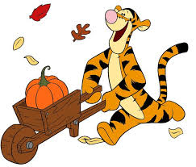 |  |  | 1  Paper toothbrush | 2  Dental hygiene food match | 3  F is for “Fall” | 4
5 | 6  Leaf Stamping | 7  Straw Stamping Corn | 8  Tissue Paper Fall Tree | 9  Handprint Acorn | 10  Sunflower with Seed |   11
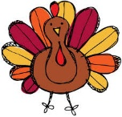  12 | 13  Closed  Thanksgiving Day | 14  Leaf Fox | 15  Fork Stamping Fall Tree  Noah’s B-Day | 16  Pumpkin Pie   | 17  H is for “Harvest” | 18
19 | 20  Black Cat | 21  Paperplate Scarecrow | 22  Corn in the Cob | 23  Paper Bag Turkey | 24  Scary Pumpkin | 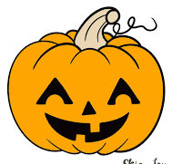  25
26 | 27  Crazy Apple  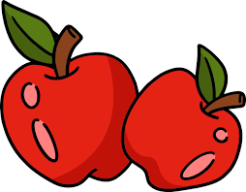 | 28 Fieldtrip  Pumpkin Patch  Bring $4 | 29  Bat Stamping | 30  Harvest Party  Please No Scary Costumes | 31  S is for “Scarecrow” | 