Tigger’s Too Playschool and Preschool (Saanichton)
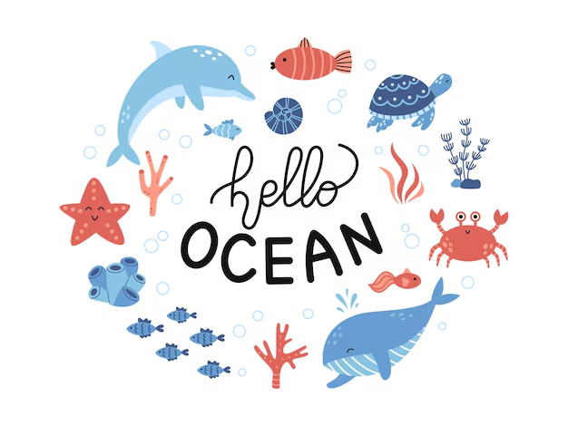

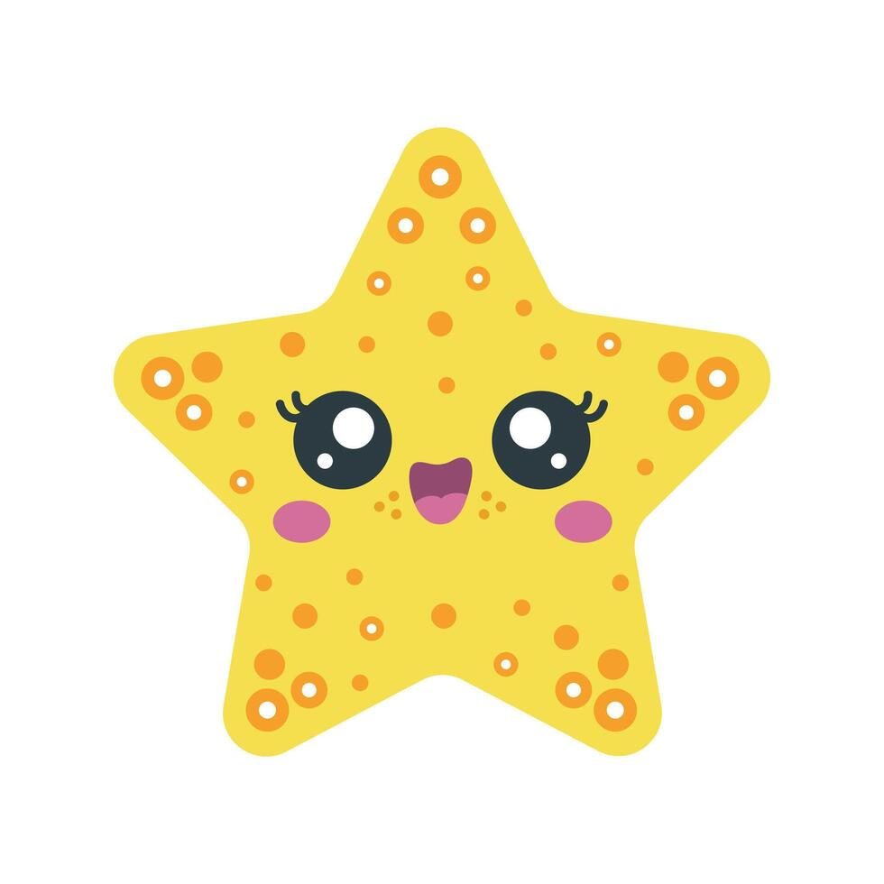
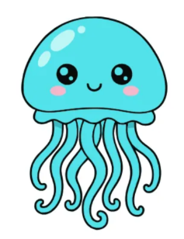


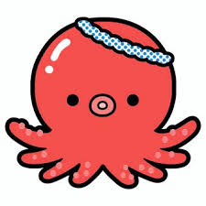
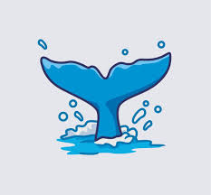

Sun | Mon | Tue | Wed | Thu | Fri | Sat
June 2026 Theme: Ocean Explorers
 | 1  Ocean Relay Race | 2  Whale Tail Art | 3  Paper Chain Octopus | 4  Ocean Sponge Painting | 5  Seashell Decorating | 6
7 | 8  Graduation day  At 5:30  Fishing for Numbers | 9  Fingerprint Fish Counting | 10  Number Matching with Sea Animals | 11  Turtle Shell Mosaic | 12  Feed the Shark | 13
14 | 15  Crab Walk Race | 16  Jellyfish Ribbon | 17  Sea Turtle Plate | 18  Make  Family card | 19  Pro D-day  (Centre closed) | 20
21  Father’s day | 22  Find the Fish Hunt | 23  Puffy Fish Craft | 24  Starfish Craft | 25  Octopus Handprint | 26  Wave Parachute Game | 27
28 | 29  Slow Turtle Race | 30  Pattern Tentacles | Summer Break  - July 2nd - July 3rd  - Reopen - July 6th, Monday

