Tigger’s Too Toddler Class Playschool (Saanichton)






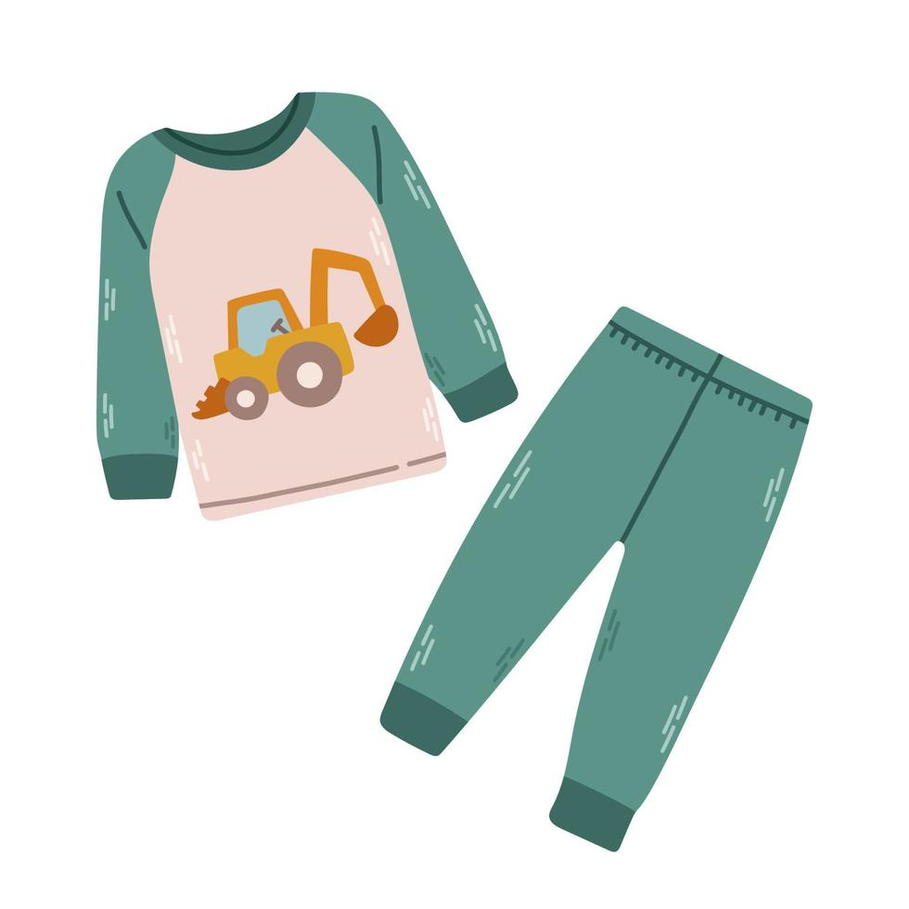



Sun | Mon | Tue | Wed | Thu | Fri | Sat
June 2026
Theme: We love Camping
 | 1  Foil Painting Campfire | 2  Counting Firefly | 3  Colorful Lantern | 4  Jump Jump  Stepping stone | 5  Pajamas day  (Song & Dance) | 6
7 | 8  Star stamping | 9  Fishing game | 10  Marsh mallow  painting | 11  Color Fish | 12  Yum Yum  Smore | 13
14 | 15  Camping  Lantern with light | 16  Forest at night | 17  Hooray for  Fish | 18  Make  Family card | 19  Pro D-day  (Centre closed) | 20
21  Father’s day | 22  Firefly suncatcher | 23  Bug  Rescue & Sort | 24  My own Binoculars | 25  Painting with Nature | 26  Going on a bear hunt | 27
28 | 29  Let’s see  Projectors  (Camping theme) | 30  Let’s  Water play  (swimsuit & towel) | Summer Break  - July 2nd - July 3rd  - Reopen - July 6th, Monday

